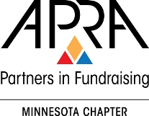
Please complete if you are interested in serving on the APRA-MN board, or if you’d like to nominate a qualified candidate.

About the Nominee:
Name:
Address:
City, State, Zip:
Daytime Phone:
Evening Phone:
Email:
Title:
Organization:
Nominee’s Supervisor:
Supervisor’s Title and Phone
About You, the Nominator:
Your name:
Your Title/Org:

- Please list professional qualifications or attach nominee’s current resume to this form (summarized information will appear on the ballot sent to members following the fall conference on October 20, 2015).

- Briefly explain your reasons for wanting either you or your nominee to serve on the APRA-MN Board and outline the positive contributions that you or your nominee could make.

- Please describe volunteer involvement with APRA, AFP, CASE or other philanthropic organizations or boards.

